Clock Application using Java Swing

Created 6 classes with ClackMain.java as the main class.

The Main class creates 4 tabs:

Clock, Calendar, StopWatch and CountDown Timer

* 1st Tab: Clock

Consists of Analog and Digital Clock which are synchronized with the system clock.

The code for Digital clock is in the DigitalClock.java file.

And the code for Analog Clock is in the AnalogClock.java file.

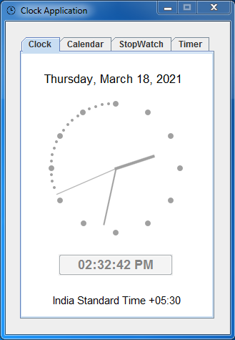

The Digital Clock class displays the Current Date at the top, followed by the current time in digital and lastly the TimeZone with the Offset Id.

The Analog Clock class displays the graphical representation of an analog clock synchronized with the system clock, along with the clock hands and hour, minutes, seconds references.

* 2nd Tab: Calendar

Consists of a Calendar Graphic which displays the date along with the calendar table for that month.

The code for Calendar is in the CalendarPanel.java file.

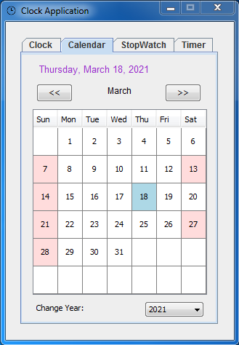

The Calendar class displays the current date in full, as well as the Calendar graphic which has separate colors for Sundays and alternate 2nd Saturdays. And a Different Color representing the current date.

A box along the bottom lets you select a different year, two buttons above the Calendar to select the previous and next months.

* 3rd Tab: StopWatch

Consists of a StopWatch which starts counting the time when the start button is pressed.

The code of StopWatch is in the StopWatch.java file.

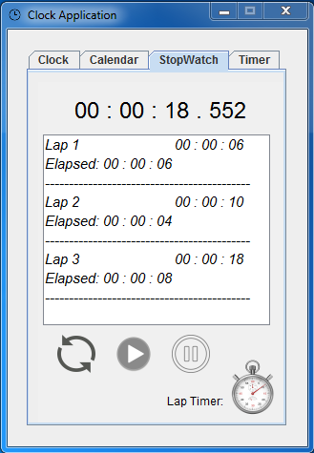

The StopWatch time is synchronized with the System clock. To calculate the time System.currentTimeMillis() is being used.

There are three buttons to manipulate the stopwatch, reset, start and pause. When the start button is pressed, it starts counting the time, pause button halts the count until start is pressed again. The reset button resets the counter.

There is a Lap Timer button which counts the lap time (timed sessions) when the button is pressed. Each lap is calculated from the time when the previous lap was recorded. The reset button clears the laps.

* 4th Tab: CountDown Timer

Consists of a timer which counts down the time from the selected values.

The code of CountDown Timer is present in TimerPanel.java file.

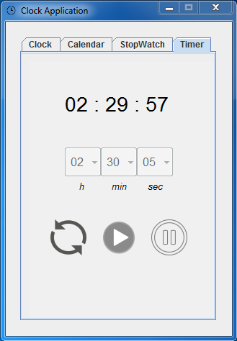

The h, min and sec boxes are used to select the time. The below buttons reset, start and pause manipulate the entered time. When the start button is pressed, it starts counting down the entered time. Pause button halts the time and reset button resets the counter.

* References used:

For Digital Clock - <https://www.javatpoint.com/digital-watch>

Analog Clock - <https://github.com/paoloboschini/analog-clock/blob/master/Clock.java>

Calendar - <https://javahungry.blogspot.com/2013/06/calendar-implementation-gui-based.html>

StopWatch - <https://stackoverflow.com/questions/33487186/swing-timer-stopwatch-in-java>

CountDown Timer - <https://www.youtube.com/watch?v=xrmu6Y4Mba0&ab_channel=StudyViral>

* Bugs:

In Calendar:

Clicking cells from the same row one after the other doesn’t invoke the listSelectionListener

for that, we have to use TableModelListener

Refer answer of: <https://stackoverflow.com/questions/60557795/selecting-single-row->twice-in-jtable-does-not-calls-the-listselectionlistener-va

In CountDownTimer:

It is not properly synchronized with the System Clock as a method is used to increment integers to keep track of time rather than System.currentTimeMillis()

The delay is approximately 1 second for each minute that passes.